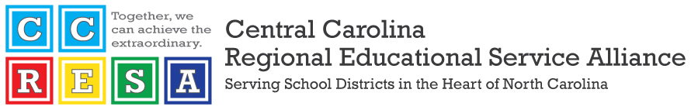

**Meeting: Board of Directors  
Date: February 9, 2024   
Time: 9:00 a.m. - 12:00 p.m.  
Location: CCRESA Assembly Hall**

**Agenda**

| Time | Agenda Item | Notes/Links |
| --- | --- | --- |
| 9:00 | Welcome (Breakfast sponsored by Once) | Dr. Patrick Miller |
| 9:05 | Once | Tarah Taylor |
| 9:15 | Approval of December 12 Minutes | Dr. Lane Mills |
| 9:17 | Approval of Financial Reports | Keith Sutton |
| 9:20 | Update on early graduation/PBR parent guide requirement | Sneha Shah-Coltrane, Director of Advanced Learning & Gifted Education - NCDPI |
| 10:00 | Igniting Principal Engagement | Tabari Wallace, Special Advisor to the Superintendent for Principal Engagement |
| 10:20 | Break |  |
| 10:30 | Update on Infinite Campus | Dr. Rob Dietrich, Senior Director of the Office of Digital Teaching & Learning - NCDPI |
| 11:00 | Hot Topics in Education: New Statutory Reporting Requirements for Schools | Brian Shaw, Poyner Spruill |
| 11:45 | Adjourn/Lunch sponsored by Kloud-12 |  |

**Next Board of Directors Meeting: March 15, 2024**

