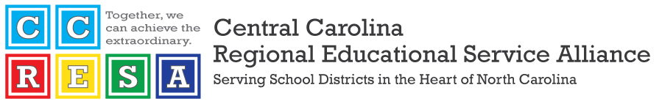

To: CCRESA Board of Directors

From: Dr. Patrick C. Miller

Date: February 9, 2024

Re: Executive Director’s Report

**CCRESA Council Meetings**

No job-alike councils have met since our last meeting on December 12.

**Central Carolina Principal Preparation Program (CCP3)**

Thank you for returning the CCP3 MOUs in a timely manner. CCP3 offered slots in Cohort 4 to 18 candidates. The candidates were notified of their acceptance on Wednesday, January 31. Thus far, 16 candidates have accepted slots.We have hit our target goal of 16 students. The deadline for accepting slots is February 23rd. Classes for Cohort 4 will begin in the fall of 2024.

**CCRESA at SBE Meetings**

The following CCRESA superintendents have agreed to attend SBE meetings, per Jack Hoke’s request, for the spring semester:

* March 6-7, 2024: Dr. Cindy Bennett (Vance)
* April 3-4, 2024:
* April 30-May 2, 2024: Dr. Rodney Peterson (Person)
* June 5-6, 2024:

**Conferences/Professional Travel**

I attended the following conferences/events since our last meeting on December 12:

* NCASCD Annual Conference in Pinehurst on January 31-February 2..

I am registered to attend the AASA National Conference on Education on February 13-17, 2024. I am also registered to attend the annual meeting of the superintendents and community college presidents at the Grandover on February 27-29.